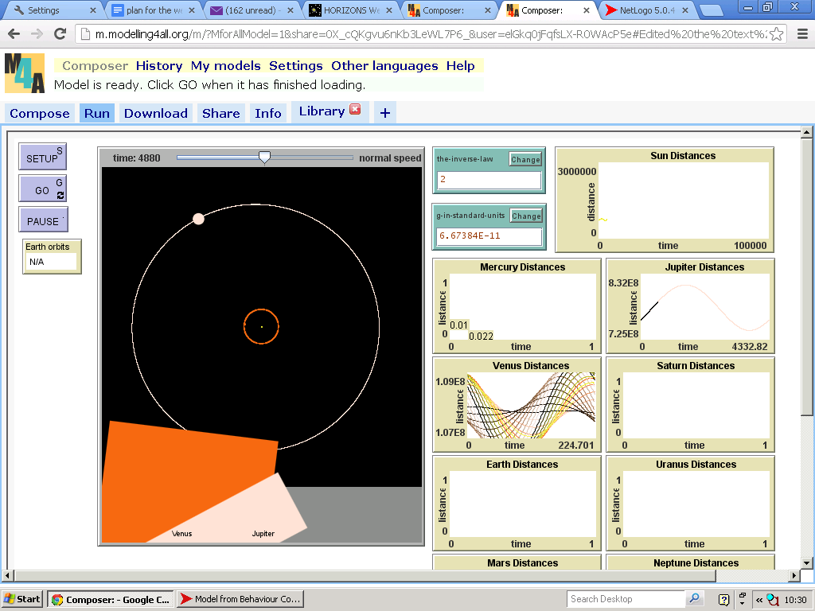Document 2

Solar System with only Venus and Jupiter

We noticed that the orbit of Venus was alternating between an elliptical and a circular orbit. When in the elliptical orbit the size of the orbit was far larger than any sources suggested it would be.

To find the source of the discrepancy we inactivated all of the other planets and the re-activated the one by one. I was sure that either the more massive or the closer planets would have more of an effect on the Venuses orbit. The trial showed that Venus had a regular orbit right up until Jupiter was introduced. This shows us that the mass of Jupiter is somehow causing the orbit to skew, the reason for this we believe will be the fact that we have not set the z-axis as the model is not in 3-d. This is because without the third dimension the two planets where mush closer than they would be otherwise because they are on the same plane rather than being on different planes.

As the coordinates of the z-axis are so small for most planets we decide originally that it wouldn’t make much of a difference on to the orbits of the planets if we didn’t include this dimension. After this we think we might benefit from a 3-d model a lot more. The print screen below shows the coordinates of Venus (at 00:00 01/01/2013) as you can see the z coordinate is not insignificant. Other planets which mig, this is why we believe it effects the orbit of Venus but no other planets.

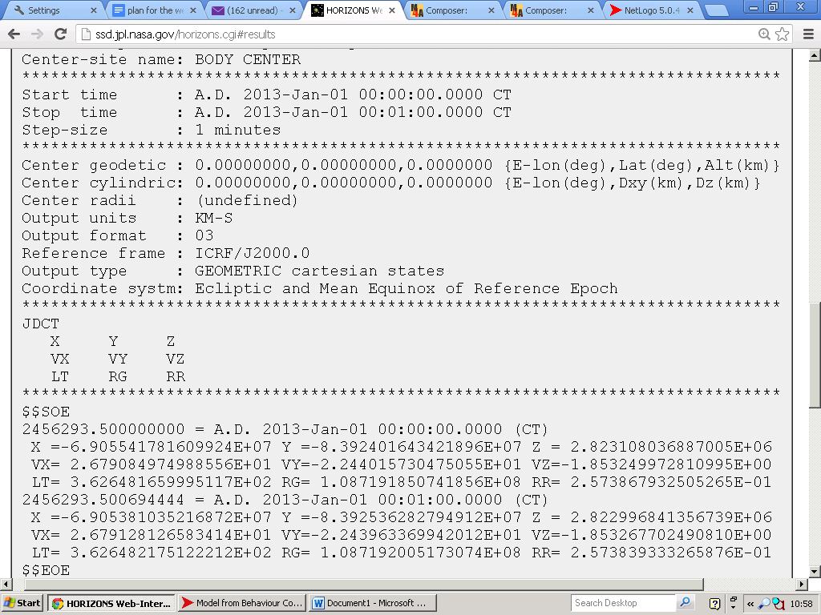

This show that initially the only planets really affecting the z-plane are objects 7 and 8 which are Saturn and Jupiter this is clearly having an effect on some orbits ie. Venus.

(object 10): -0.8473294585603292

(object 7): 0.11605353921823548

(object 4): -0.01857639771037756

(object 9): 0.0099460748621894

(object 8): -0.3784511797695848

(object 5): -2.9366300010965845E-5

(object 6): -0.04843050145156117

(object 3): -0.04644628553731377

(object 2): 4.0277236266371316E-5

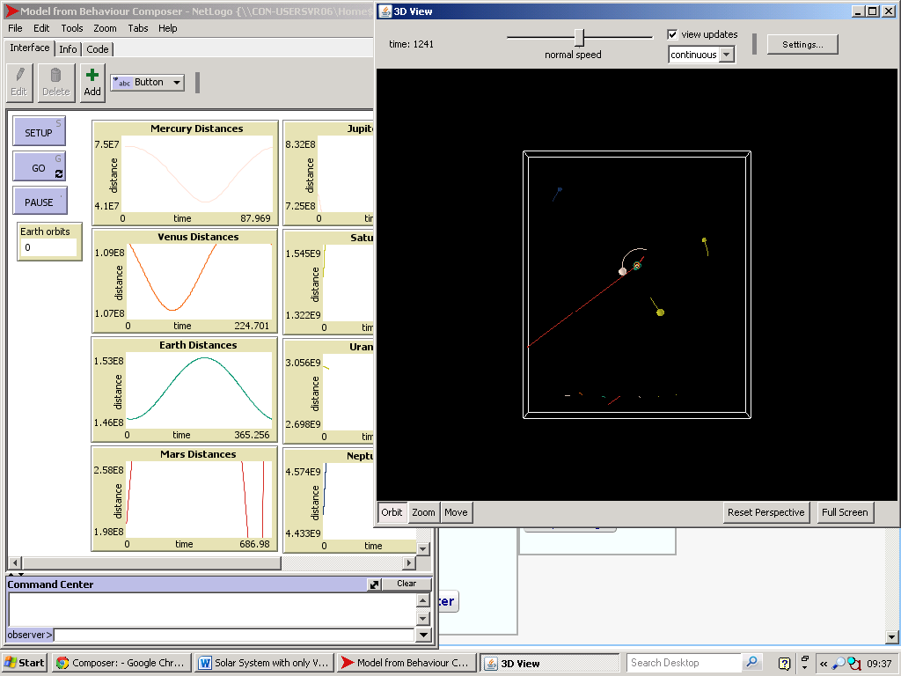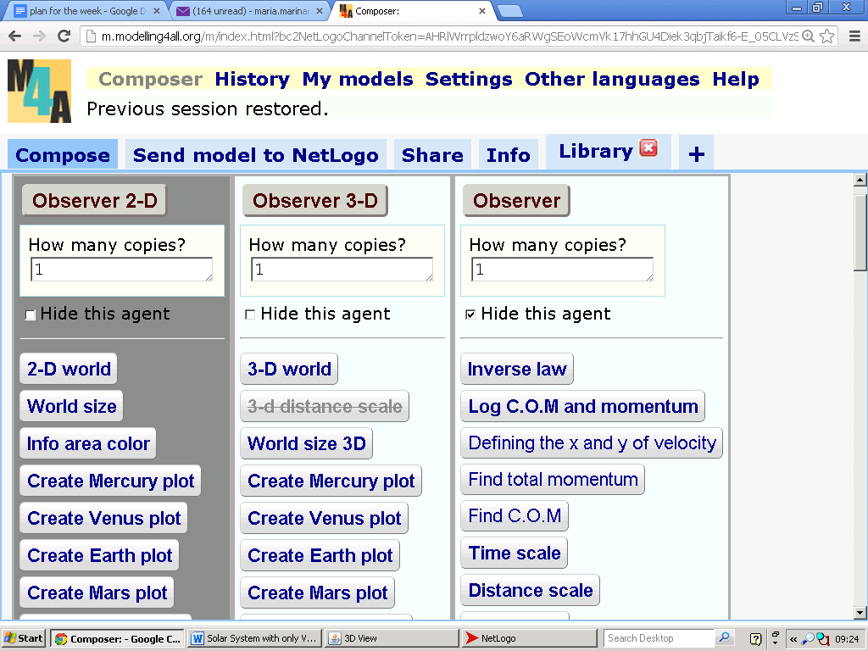When we started making the 3-D version of obiters 1 we wanted the model to still work in 2-D because the 2-D version of netlogo is simpler to run and can be easily accessed in an internet browser. Trying to make the model run in both 2-D and 3-D simultaneously made our job very hard because there are some types of code that we need in the 3-D version of Netlogo that a 2-D version will not understand (pitch, heading, roll, setxyz etc.). To get around this problem we created an additional two observers which could be activated or inactivated depending on which version of Netlogo you are using (shown to the right). However because the 3-D version of Netlogo is not as developed as the 2-D version, as it hasn’t been established for as long, we encountered a number of problems. The main one being that the gravity feature would not work in the 3D version because the bodies were being affected by the gravitational pull of bodies on the other side of the screen. We also discovered our pervious trigonometric method of finding the new angles between planets wouldn’t work in 3-D, atan xy instead we had to find the pitch that the bodies would be acting on in the end we found that.

[**set**](http://ccl.northwestern.edu/netlogo/docs/dictionary.html#set) pitch [**atan**](http://ccl.northwestern.edu/netlogo/docs/dictionary.html#atan) z ([**sqrt**](http://ccl.northwestern.edu/netlogo/docs/dictionary.html#sqrt) ( x [**^**](http://ccl.northwestern.edu/netlogo/docs/dictionary.html#Symbols) 2 [**+**](http://ccl.northwestern.edu/netlogo/docs/dictionary.html#Symbols) y [**^**](http://ccl.northwestern.edu/netlogo/docs/dictionary.html#Symbols) 2 ))

Works for this, there were also lot of other smaller problems involving the graphs complete orbit and the velocity monitors.

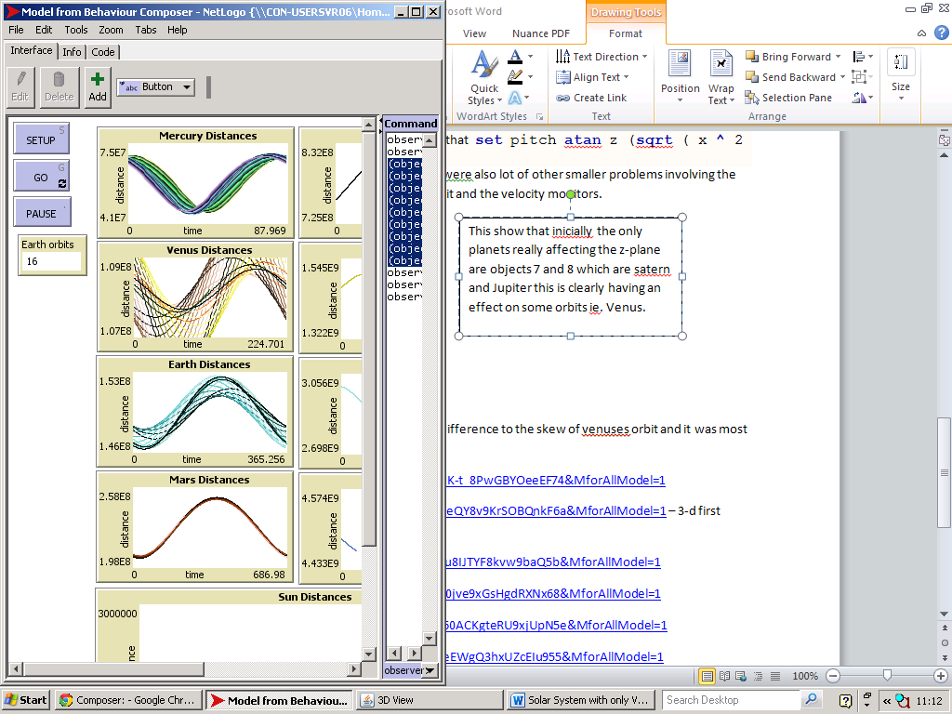

After finding that the 3-D version made little difference to the skew of Venus’ orbit and it was most definitely the effect of Saturn and Jupiter that.

When we measured the distance Venus was travelling on the z plain we found it to be an exact sin wave showing that the overall effect on the plot Venuses distance from the sun should show the addition of the two sin waves constructively interfering which it does. Al though in terms of finding the problem with Venuses orbit this exercise was fruitless. However third did massively improve the model as we could now set up models that would 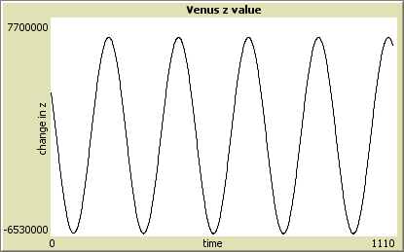

The momentum and the com of the solar sysem.

<http://m.modelling4all.org/m/?frozen=eQ_sdK-t_8PwGBYOeeEF74&MforAllModel=1>

<http://m.modelling4all.org/m/?frozen=O64IHeQY8v9KrSOBQnkF6a&MforAllModel=1> – 3-d first version

<http://m.modelling4all.org/m/?frozen=59gT2u8IJTYF8kvw9baQ5b&MforAllModel=1>

<http://m.modelling4all.org/m/?frozen=-kBGR0jve9xGsHgdRXNx68&MforAllModel=1>

<http://m.modelling4all.org/m/?frozen=uGLO60ACKgteRU9xjUpN5e&MforAllModel=1>

<http://m.modelling4all.org/m/?frozen=h-mLieEWgQ3hxUZcEIu955&MforAllModel=1>

<http://m.modelling4all.org/m/?frozen=XzqtMevbT72vBDJa4c1O5g&MforAllModel=1>

<http://m.modelling4all.org/m/?frozen=vZpDDu3TQ0r6lqzpgvDg7f&MforAllModel=1>

http://m.modelling4all.org/m/?frozen=nY-d_KUn0ne_zh5AVd3d6c&MforAllModel=1